|  |  |
| --- | --- |
|  | **FPT ACADEMY INTERNATIONAL**  **FPT – APTECH COMPUTER EDUCATION** |

e - Project

Merciadoamusementpark.com

Instructor: Le Mong Thuy

Batch: T1.1907.M0

Team: Group 5

Student:

|  |  |  |
| --- | --- | --- |
| No | Full name | ID |
| 1 | Pham Anh Duc | Student1215620 |
| 2 | Luong Truc Quynh | Student1215632 |
| 3 | Trieu Quoc Vuong | Student1218310 |
| 4 | Nguyen Trung Kien | Student1218311 |

**This is to certify that**

**Mr./Ms.:**

Pham Anh Duc

Luong Truc Quynh

Trieu Quoc Vuong

Nguyen Trung Kien

**has successfully designed & developed**

eProject: Merciadoamusementpark.com Website

**Submitted by:**

**Pham Anh Duc**

**Date of issue: 7-Oct-2019**

**Authorised Signature:**

**Synopsis**

The Internet - especially the web - has become a major source of information for people around the globe. Online library, web base training, web base marketing and selling,... are few of the many application of internet. Nowadays, people change the major portion of their usual means of getting any information from direct on site to remotely access the information via web. Plus, bringing quite a new wave of customers who search for relating technology and market information through web before deciding their purchase on site or online. It is equally true that those company which doesn't have web presence are now losing competitiveness.

Merciado Amusement park is now prime focus of the city and nation. It is made by Seth groups of companies. The development team of this park took 5 years to get their desired finished product. It has became nation pride now. The area of theme park is about 45 acre land. The Management has put all the efforts to keep the attractions operational. The merciado management wants you to develop the website of the park which should include describing all the attraction of the park and also allow the user to book the ticket online.

**Problem Statement**

Merciado Amusement park is now prime focus of the city and nation. It is made by Seth groups of companies. The development of this park took 5 years to get their desired finished product. It has became nation pride now. The area of theme park is about 45 acre land. The Management has put all the efforts to keep the attractions operational. The merciado management wants you to develop the website of the park which should include describing all the attraction of the park and also allow the user to book the ticket online.

You are supposed to create a website for them with the below mentioned requirement specifications.

The website is to be developed for the Windows Platform using HTML5, JavaScript and Geolocation. The site should work well in all leading browsers including Chrome, IE, Firefox etc.

**Requirement Specification:**

The Web site is to be created based on the following requirements.

1. The home page must be designed with beautiful color combination with all the required links defined properly. Also all the section of the webpage must be in used to avoid the blank space.
2. Different Zones and attraction, Restaurants, Entertainment, Tickets and Prices, Gallery be described in different webpage.
3. Prices value must be show the differences as per the day (like weekend or weekday or family pack).
4. About us, Contact Us, Disclaimer must be included. Location of the park in the map using GeoLocation API should be displayed.
5. Creating an account facility can also be added.
6. Dummy procedure for booking the ticket can be added.
7. Sitemap must be added.
8. Navigation of the project must be made smooth.

**CUSTOMER'S REQUIREMENTS SPECIFICATIONS**

**Client:** Seth groups of companies

**Business / Project objective:** Provide users interesting information about Merciado Amusement park

Enable users to search for points of interest, purchase ticket online.

**Input to the system:**

From Webmaster:

* Details about Merciado amusement park (Attraction, restaurants, Entertainment…)
* Details information about prices, hours of opening, address of the park.
* Administration information such as contacts, mail, as well as accounts of admin to maintain web page.

From website visitors:

* Booking tickets, ticket number.
* Users can search for points of interest.
* Creating an account facility.
* Users’ feedback.

**Output from the system:**

* Information of Merciado amusement park.
* Search results.
* get an account.
* allow tickets.
* Display result of update for webmaster.

**Hardware/ Software Requirements**

**Hardware**

* A minimum computer system that will help you access all the tools in the courses is a Pentium 166 or better
* 64 Megabytes of RAM or better

**Software**

* Notepad/HTML editor
* Dreamweaver
* IE 5.0/ Netscape 6.0

**Overall Structure of the system:**

**FUNCTION DIAGRAM OF VISITOR**

**HOME**

**PLACE TO VISIT**

RESTAURANT

GALLERY

ENTERTAIMENT

**ONLINE TICKET**

**ABOUT US**

**CONTACT**

**LOGIN - REGISTER**

**Description:**

There are some ways visitors can find information about a certain model:

- **Home**, Visitors can view information about the

- **Place to Visit**, Visitors can view information about the restaurant, about gallery, about entertainment.

+ **Restaurant**, Visitors can view information about the cuisine in restaurant.

+ **Gallery**, Visitors can view gallery of games have in the park.

+ **Entertainment**, Visitors can view information about the games in park.

- **Contact Us**, In this page a mail shortcut is put for easy envoking a mail compse session with receipt address ready filled.

- **Online Ticket**, Visitors can view information about the types of tickets for children, families, promotional tickets.

- **About us**, Visitors can learn more about the management of the park, and the history of the park.

- **Log in**, here users can login. If no account, user can register.

**TASK SHEET REVIEW 1**

|  |  |  |  |  |
| --- | --- | --- | --- | --- |
| **No.** | **Description** | **Begin Date** | **TeamMate Name** | **Notes** |
| 1 | Problem Statement | 10/7/2019 | Vuong |  |
| 2 | Requirement Specification of MerciadoAmusementPark.com Website. | Kien |  |
| 3 | DataFlow diagram | Quynh |  |
| 4 | Function Diagram of Visitor | Quynh |  |
| 5 | Function Diagram of Administrator | Duc |  |
| 6 | Task Sheet | Duc |  |
|  |  |  |  |
|  |  |  |  |

|  |  |
| --- | --- |
| **Date:** | |
| Signature of Instructor:  **LE MONG THUY** | Signature of Team Leader:  **PHAM ANH DUC** |

**VI. Web-site pages and Sitemap**

**1. Visitors interface:**

The Home page:

* The home page provides overview information that the park has.

Place to Visit page:

+ Introduce about the restaurant, about gallery, about entertainment.

Restaurant page:

+ Gallery of food have in restaurant.

Gallery page:

* Gallery of amusement parks and entertainment areas.

Entertainment page:

* Gallery of games have in entertainment.

Contact us page:

* Guest can mail queries directly to webmaster from within the browser.
* In this page a mail shortcut is put for easy envoking a mail compse session with receipt address ready filled.

Online Ticket page:

* Guest can freely choose or order the appropriate ticket.

About us page:

* Here more information about the management of the park, and about the park.
* Introduction to the park. the history and the leaders of the park.

Sitemap page:

* Show sitemap.

Please refer to sitemaps in the following page.

**CONTACT**

**LOGIN**

**ABOUT US**

**HOME PAGE**

**PLACE TO VISIT**

RESTAURANT

GALLERY

ENTERTAIMENT

RESTAURANT PAGE

GALLERY PAGE

ENTERTAIMENT PAGE

**ONLINE TICKET**

**TICKET PAGE**

**INFORMATION PAGE**

**CONTACT PAGE**

**LOGIN - REGISTER**

1. **HOME**

**NAVIGATION BAR**

**SLIDE BAR**

**Overview infomation**

**FOOTER**

1. **RESTAURANT**

**NAVIGATION BAR**

**SLIDE BAR**

**LIST of Food**

**MENU**

**FOOTER**

1. **GALLERY**

**SLIDE BAR**

**FOOTER**

**Pictures and information**

**NAVIGATION BAR**

1. **ENTERTAIMENT**

**SLIDE BAR**

**FOOTER**

**Details**

**NAVIGATION BAR**

1. **ONLINE TICKET**

**FOOTER**

**Form Booking**

**NAVIGATION BAR**

1. **ABOUT US**

**INFORMATION**

**FAQ**

**FOOTER**

1. **CONTACT**

**FOOTER**

**CONTACT**

**INFORMATION**

**MAP**

**NAVIGATION BAR**

1. **LOGIN**

**FOOTER**

**LOGIN**

**NAVIGATION BAR**

1. **REGISTER**

**FOOTER**

**REGISTER**

**NAVIGATION BAR**

**TASK SHEET REVIEW 2**

|  |  |  |  |  |
| --- | --- | --- | --- | --- |
| **No.** | **Description** | **Begin Date** | **TeamMate Name** | **Notes** |
| 1 | Indentify Entities | 7/10/2019 | Kien |  |
| 2 | ER Diagram | Vuong |  |
| 3 | Properties of Entities | Quynh |  |
| 4 | Design Table | All of team |  |
| 5 | Relationship Diagram | All of team |  |
| 6 | Structure of website content | All of team |  |
| 7 | Sitemap | Duc |  |
| 8 | Task Sheet | Duc |  |

|  |  |
| --- | --- |
| **Date:** | |
| Signature of Instructor:  **LE MONG THUY** | Signature of Team Leader:  **PHAM ANH DUC** |

**I. User Pages**

1- Home page: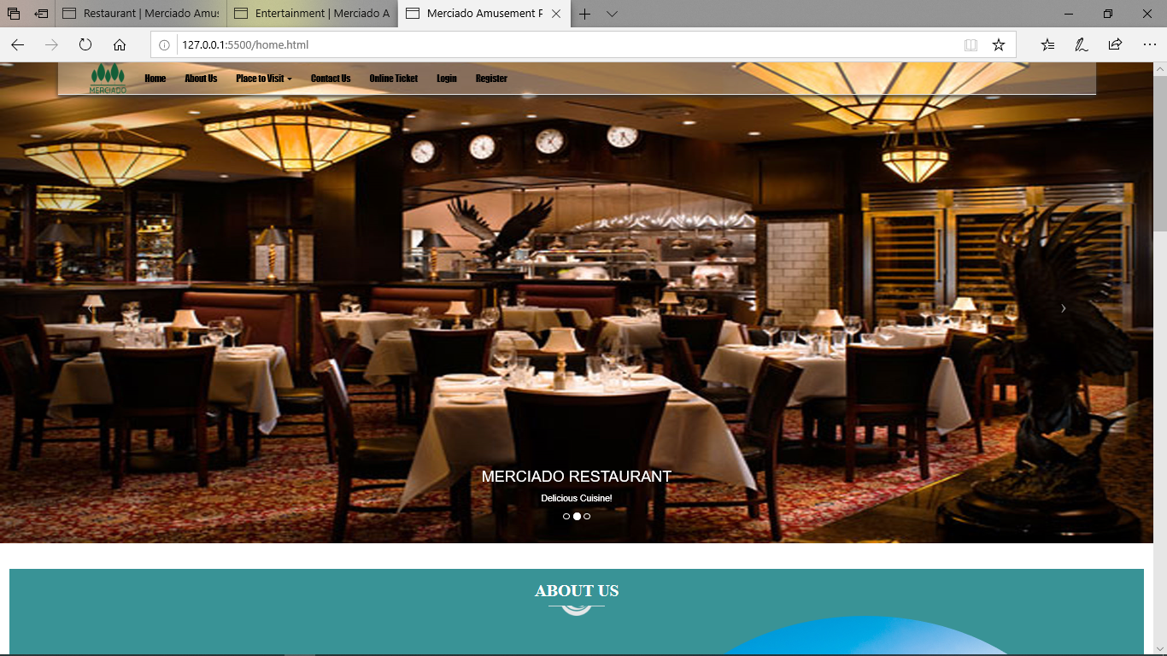

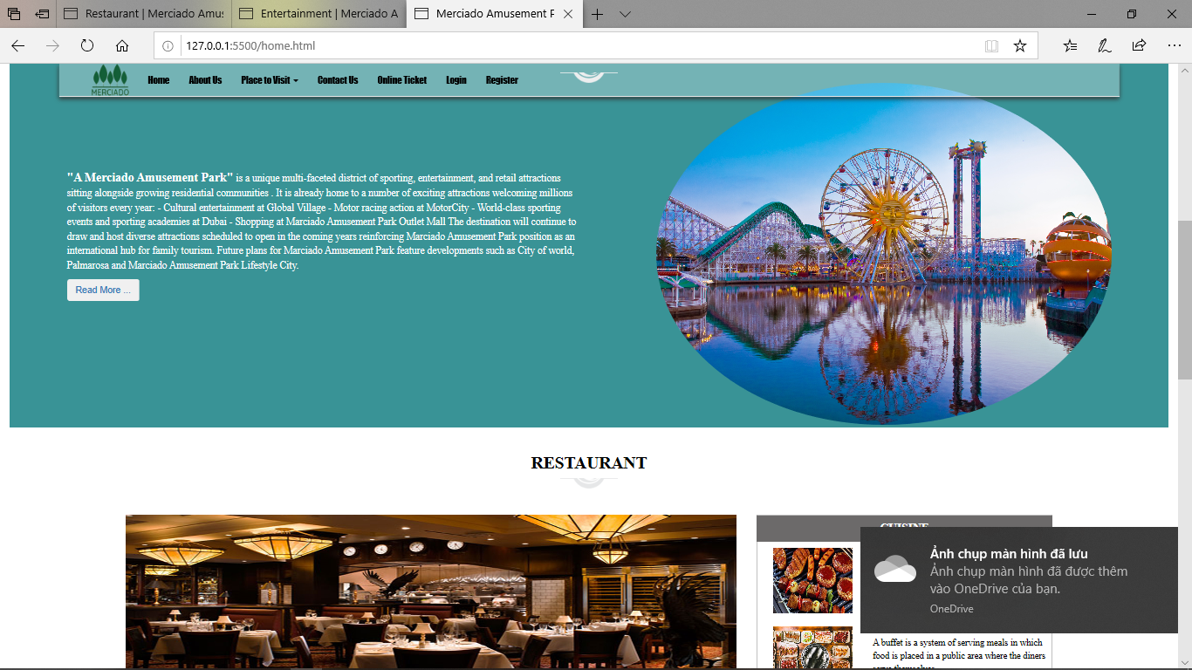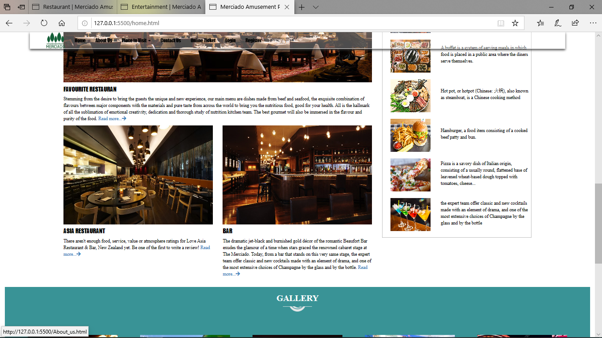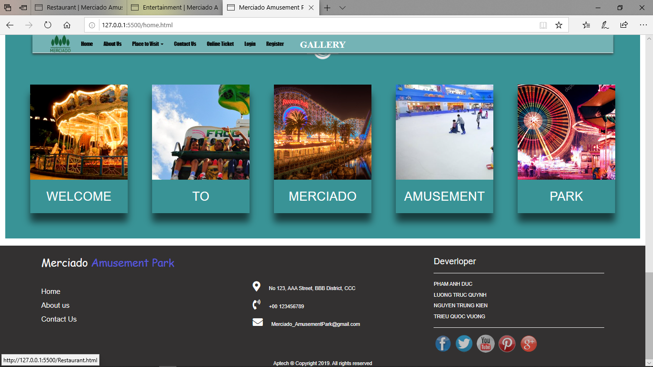

**The purpose of page**: This is the start page, it present menus for appropriate tasks and a quick model search box, the main area contains some introduction of the website.

**From page**: This is the start page

**Links to**: In this page, there are:

* Top menu: **Home**, **About Us**, **Place to Visit**,**Online-Ticket**, **ContactUs**, **Login**, **Regiter**.
* Content: links to other pages and image links
* Footer: **Copyright notice**, C**ontact information** and a **Mailto webmaster** link

The home page interface (later refered as Main Interface) will be kept as a template for all pages later, the difference between pages is on the content area only.

2-About us:

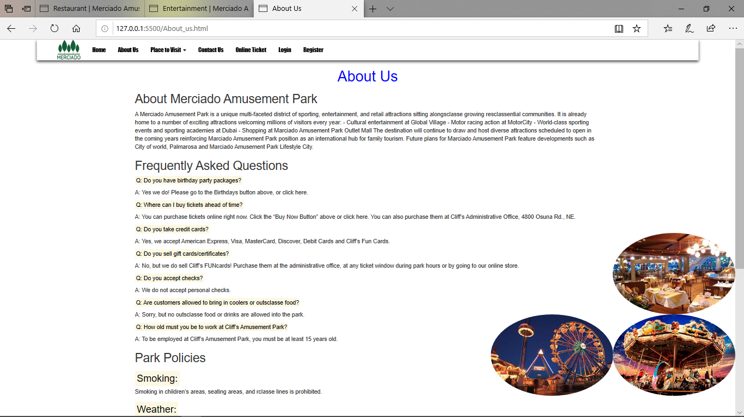

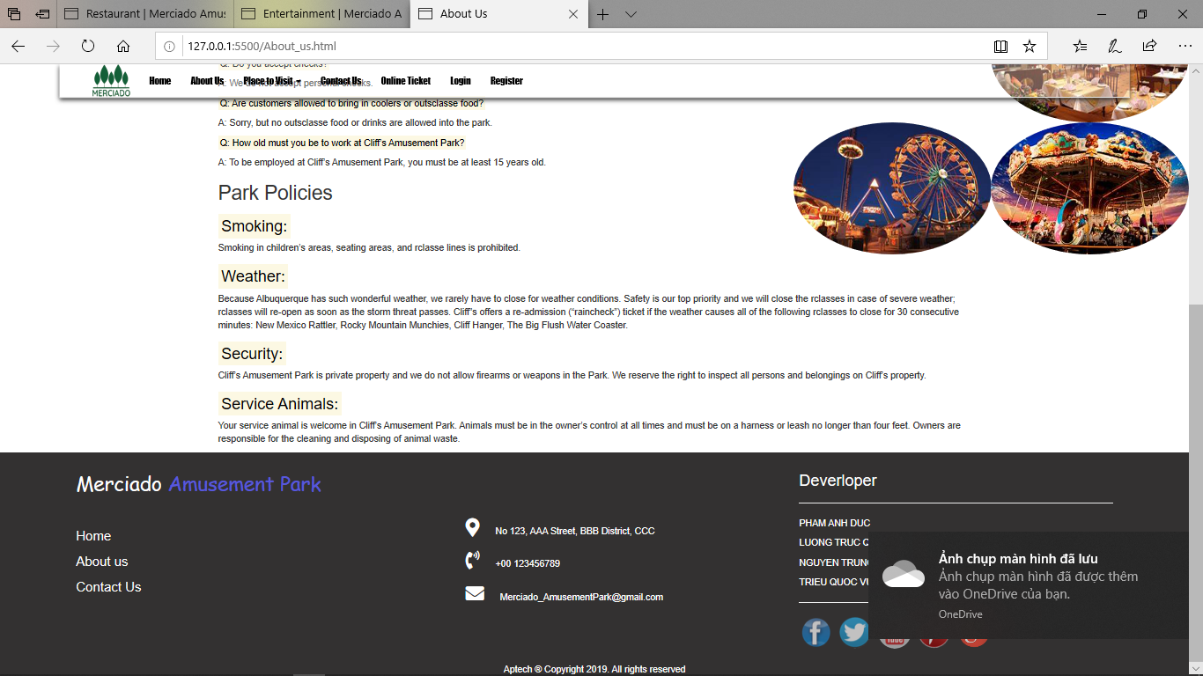

**The purpose of page**: This is the site to introduce the history and the construction of the amusement park.

**From page**: This is the start page

**From page**: Linked from in header part of the main interface.

**Links to**: Return home page.

All other functions are as in the main interface

3-Restaurant

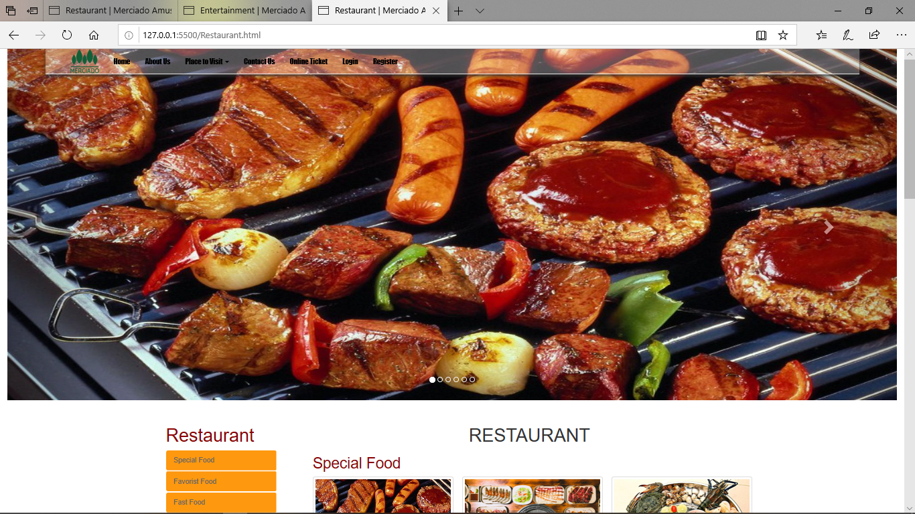

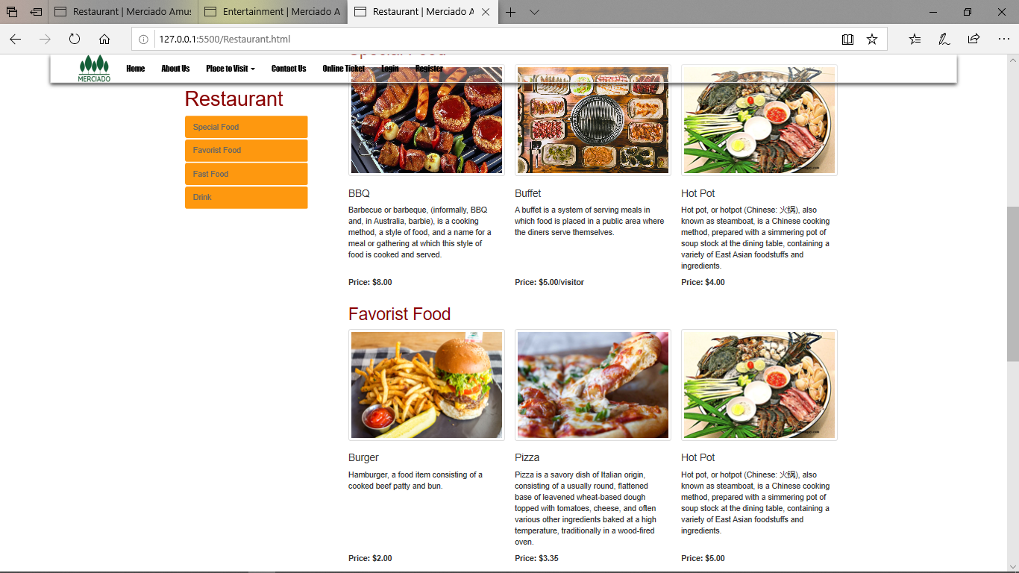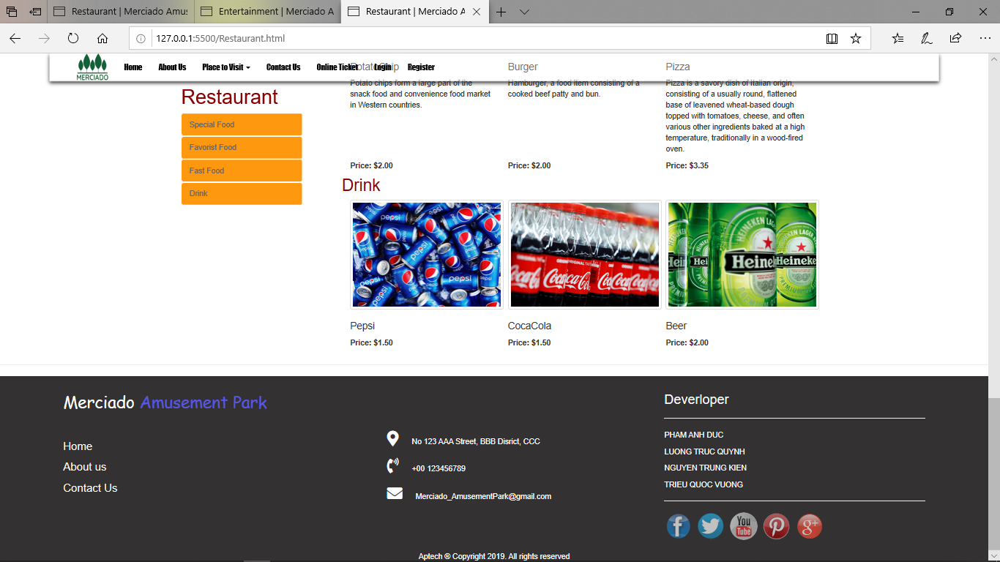

**The purpose of page**: the food page, which provides guests with the discovery and selection of the many foods served in the amusement park.

**From page**: linked from menu bar, cuisine section and images of “more food”.

**Links to** :link to subpages: **Special Food, Favorist Food, Fast Food, Drinks**, and to the **Online Ticket page**.

All other functions are as in the main interface

3-Entertainment:

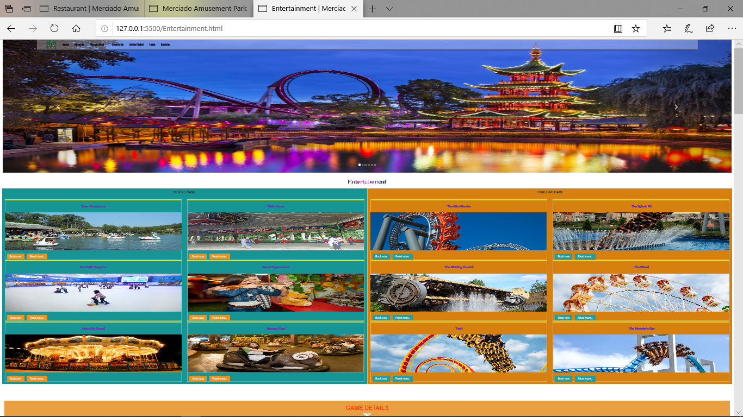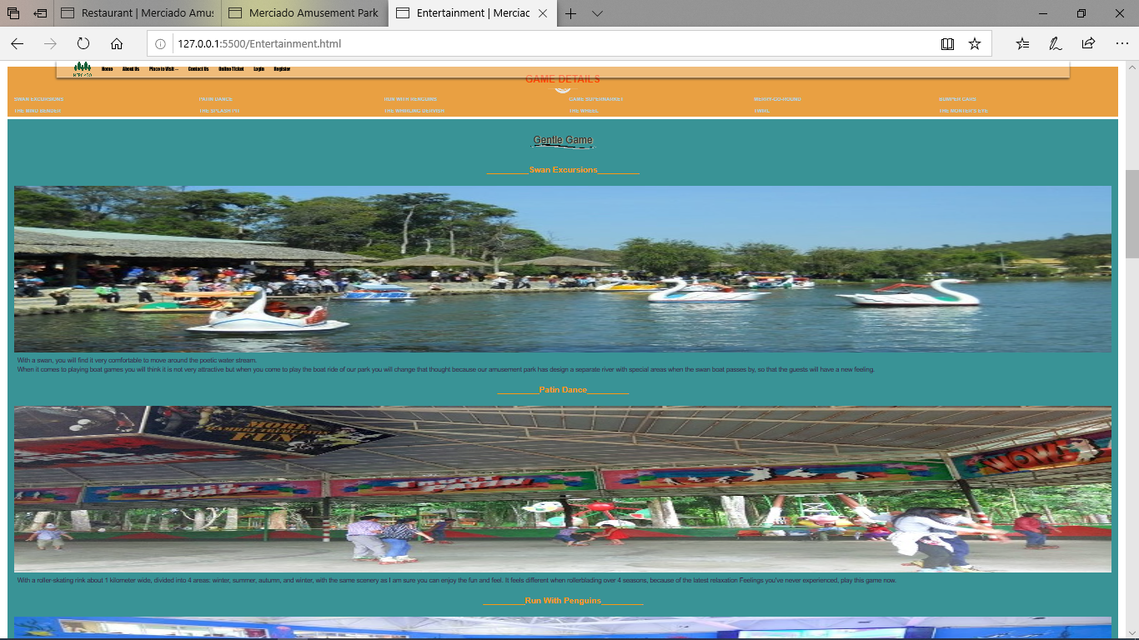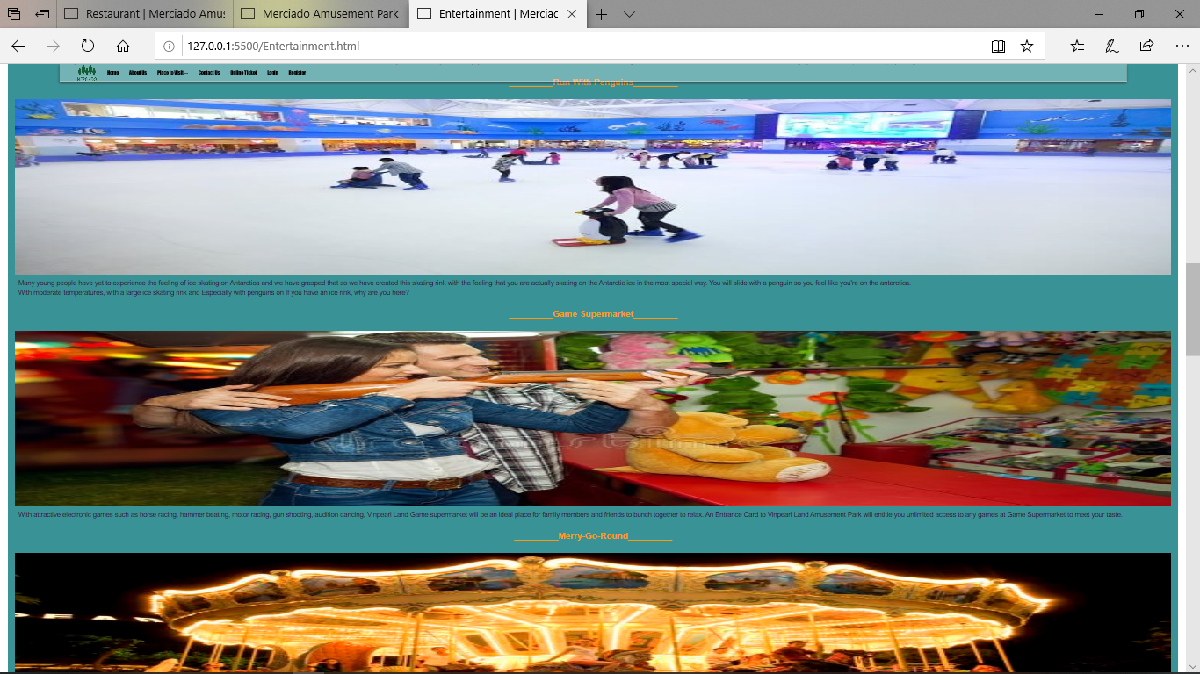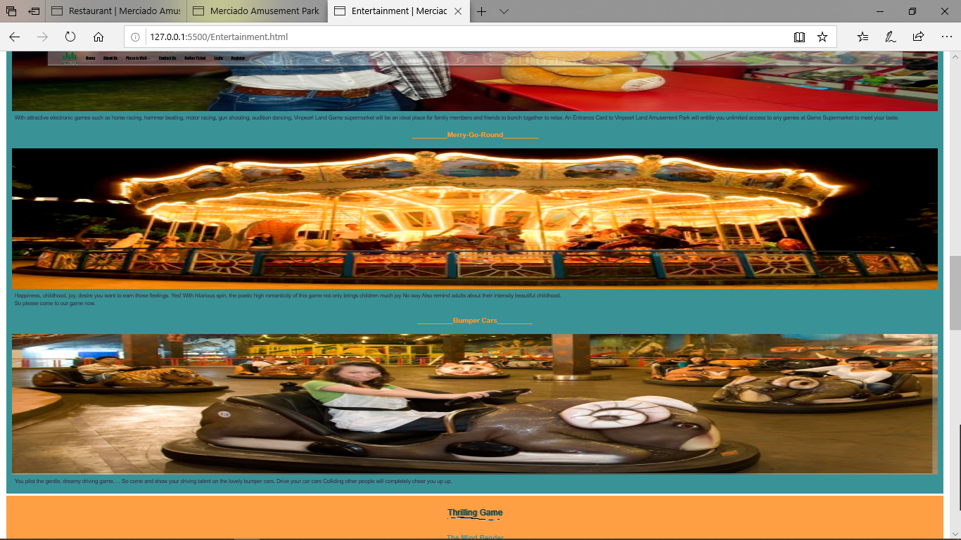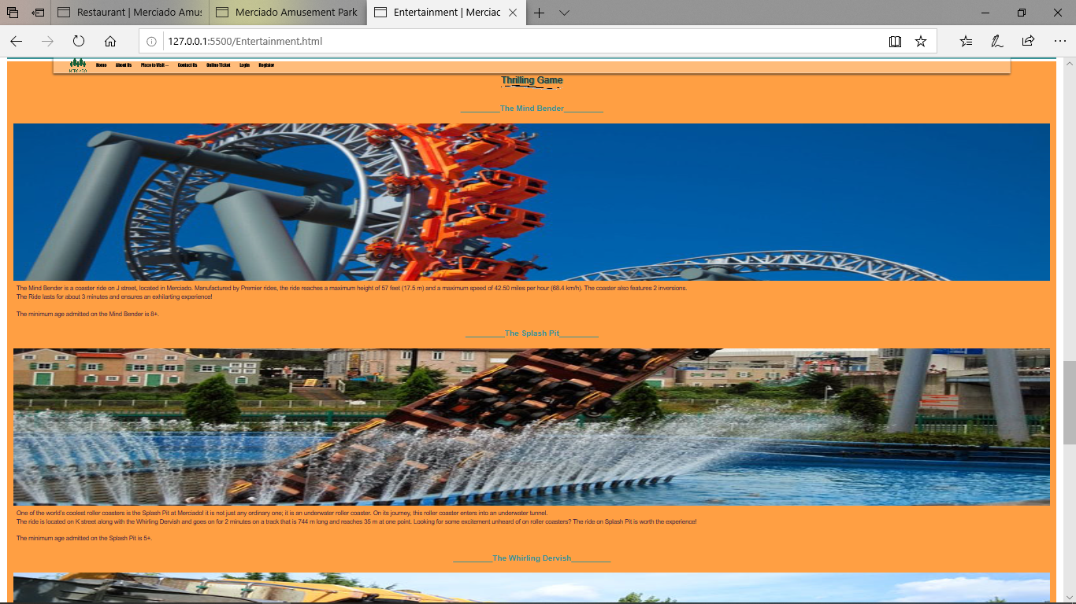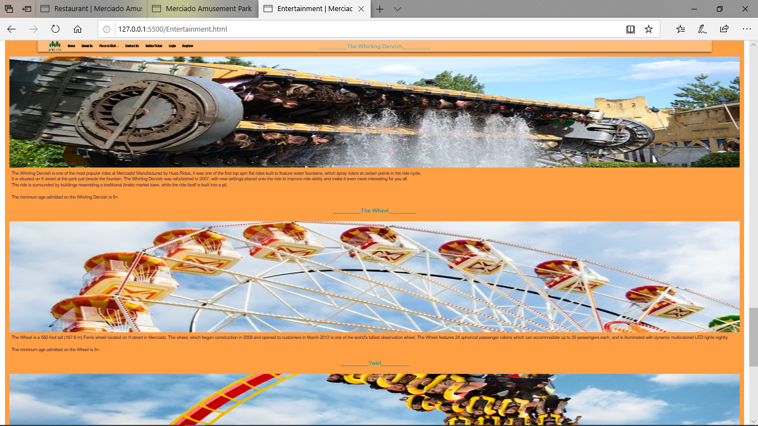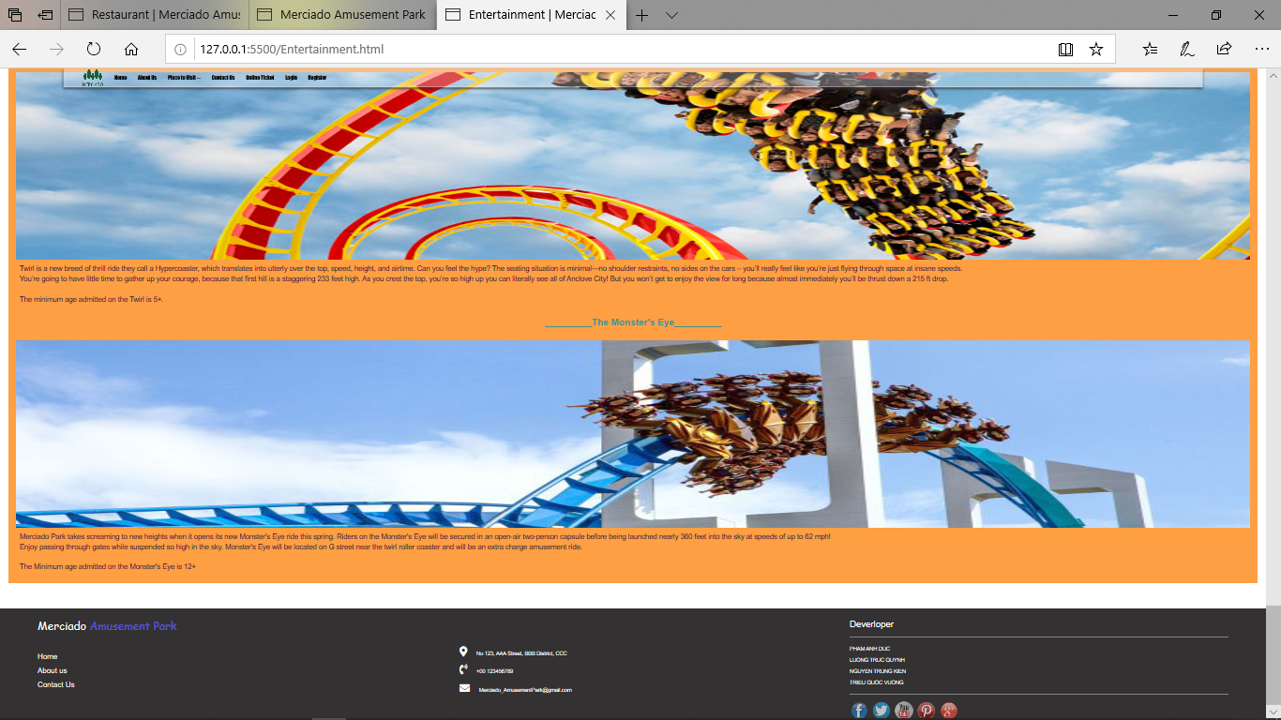

**The purpose of page**:This site helps people to find interesting and new games in the amusement park.

**From page**: get links from the homepage, pictures in the entertainment section and more interesting part.

**Links to** :go to the **Online Ticket page**.

All other functions are as in the main interface

4-Gallery

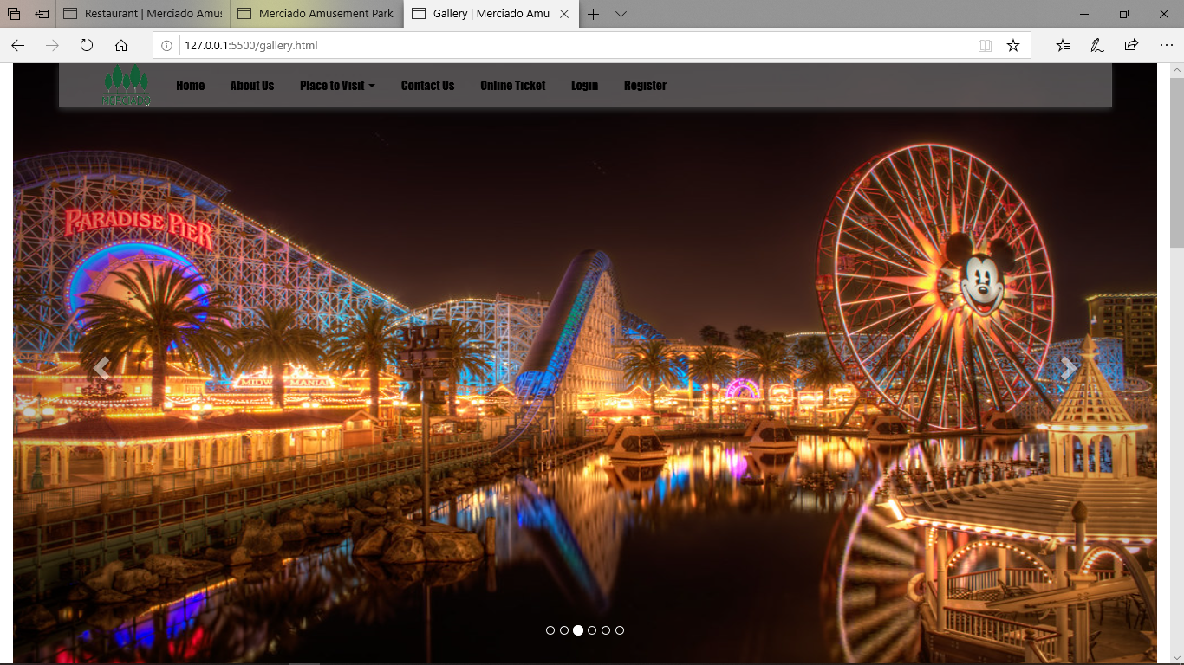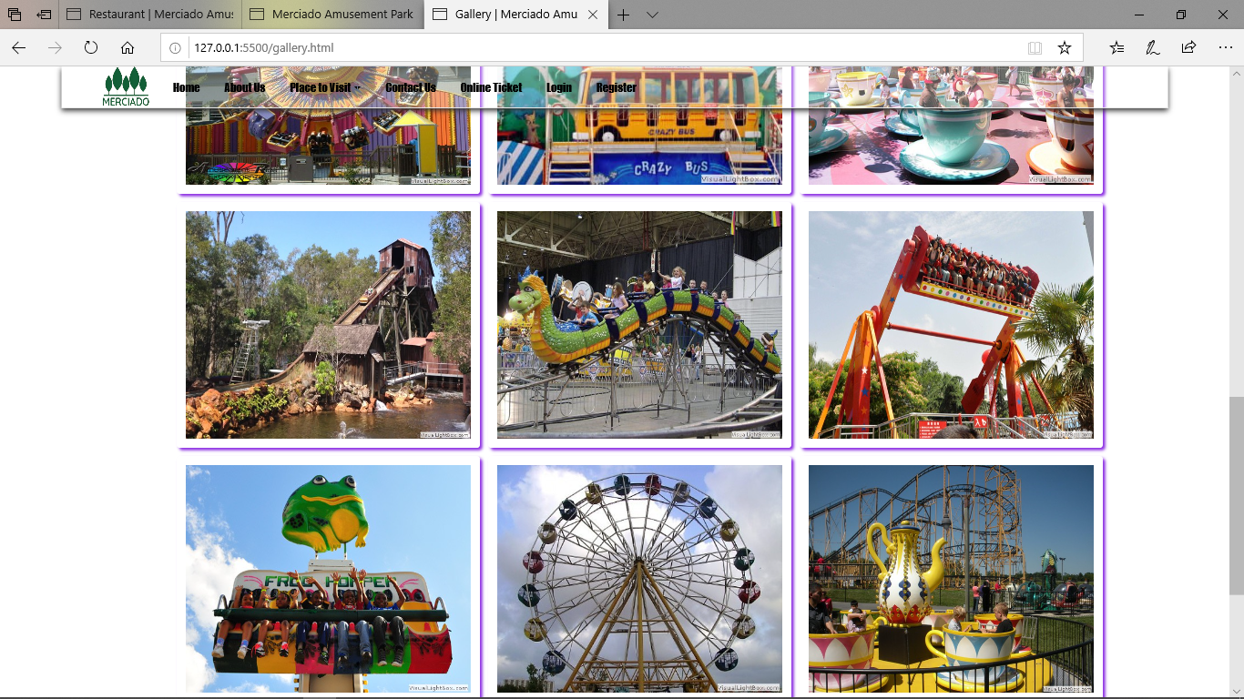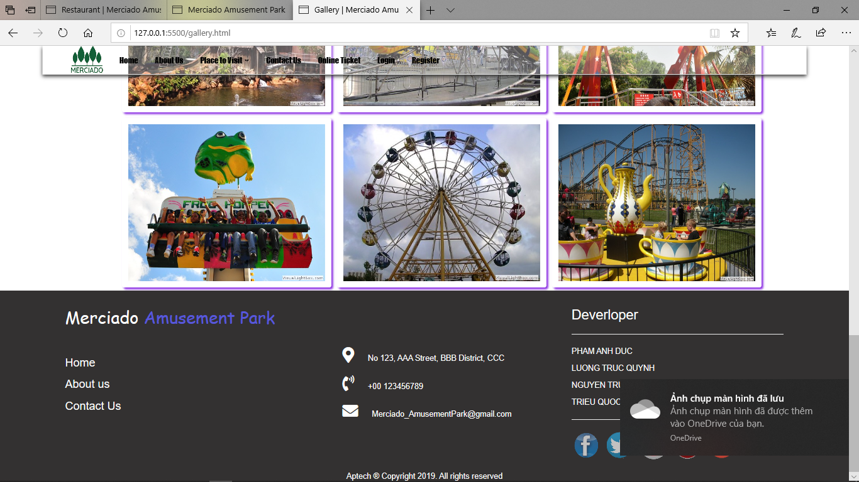

**The purpose of page**: This site helps people search for information about food and games in amusement parks.

**From page**: link from main menu, and past Place to Visit.

**Links to**: Return home page.

All other functions are as in the main interface

5-Online ticket

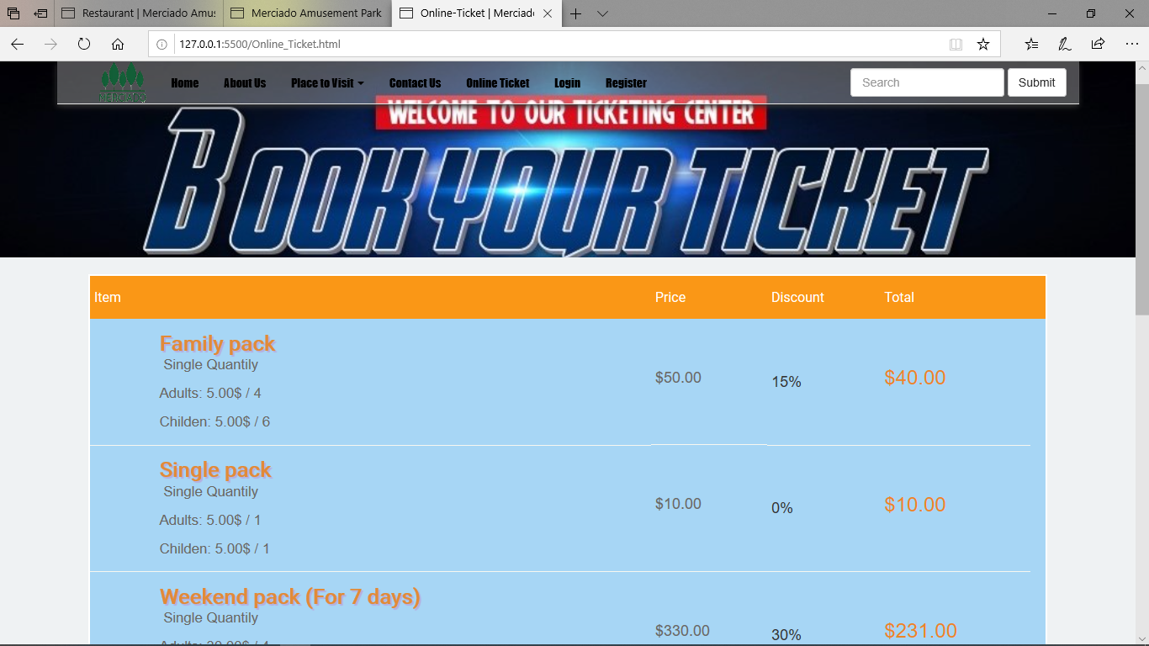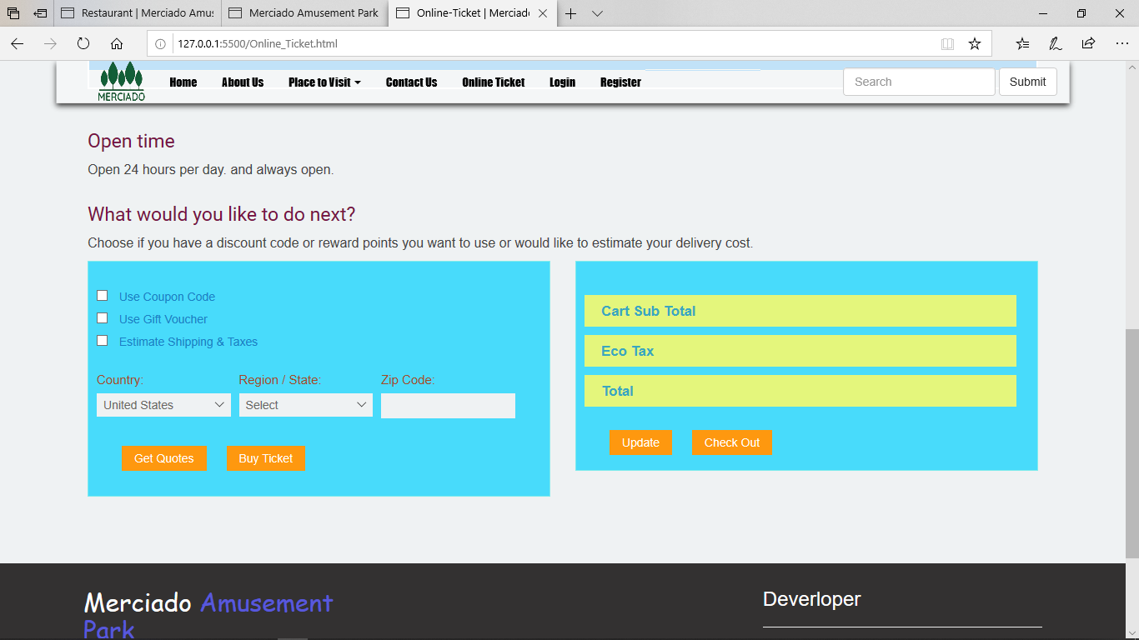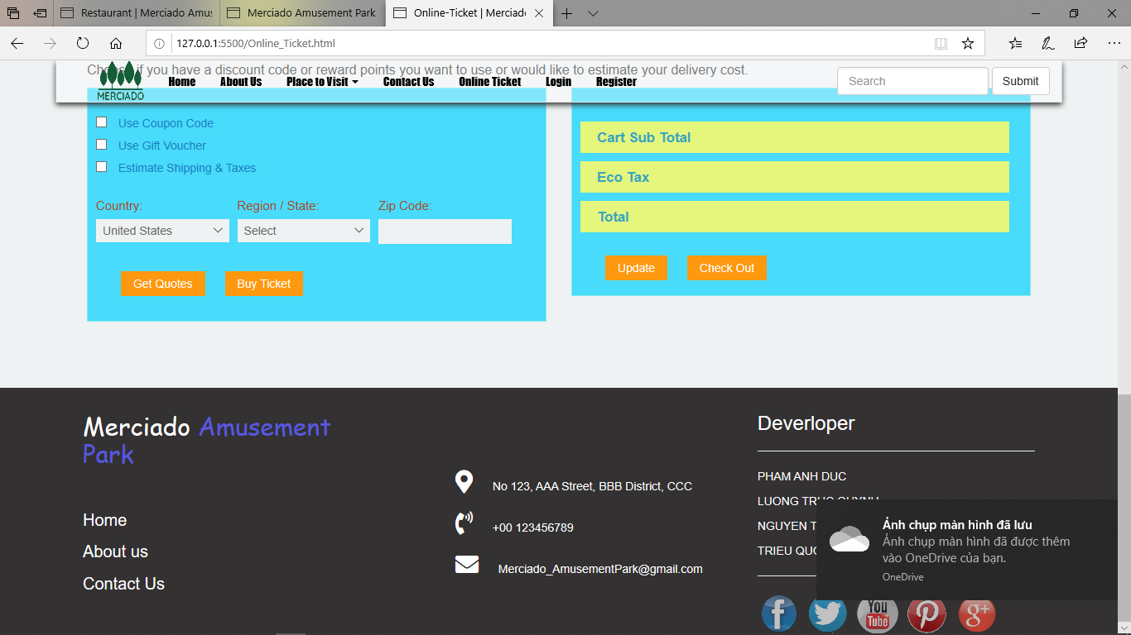

**The purpose of page**: Allows users to buy tickets and information notifications opening time of the park.

**From page**: Linked from Price – Time in main menu.

**Links to**: to the registration page.

All other functions are as in the main interface

6-Contact

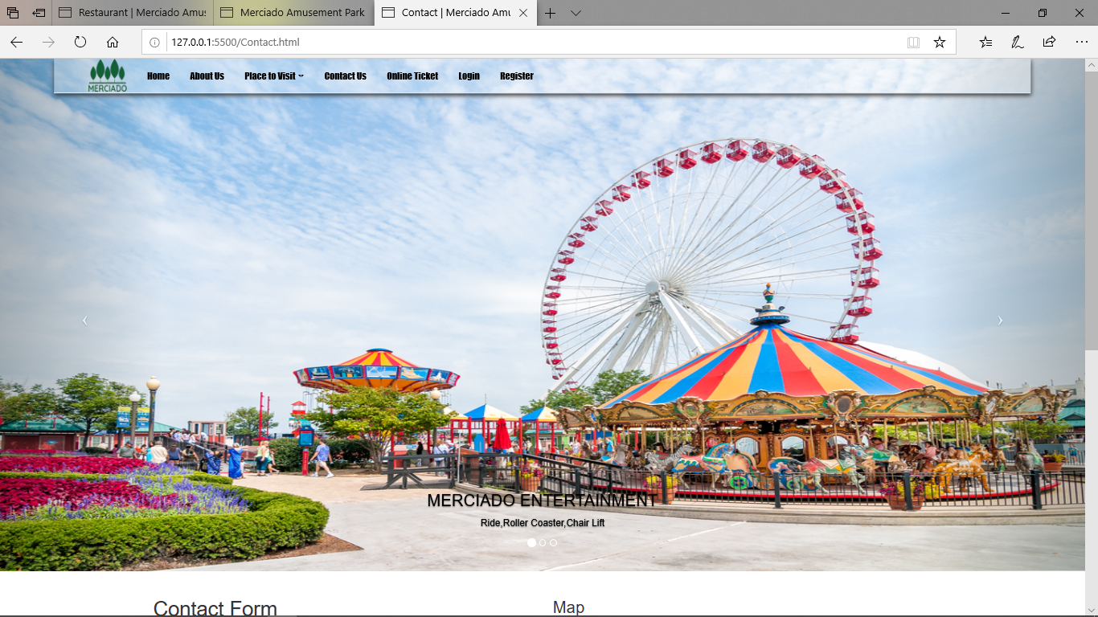

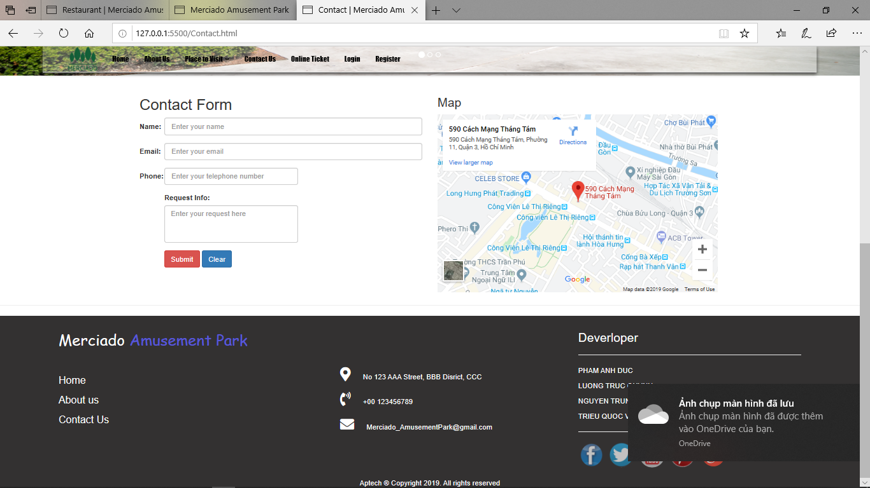

**The purpose of page**: informs users the location of the park as well as contact information for users to get in touch with the manager.

**From page**: linked from contact us in main menu.

**Links to**: on this page, when clients click on submit button, an email is sent to the manager via an authorized account.

All other functions are as in the main interface

7-Login

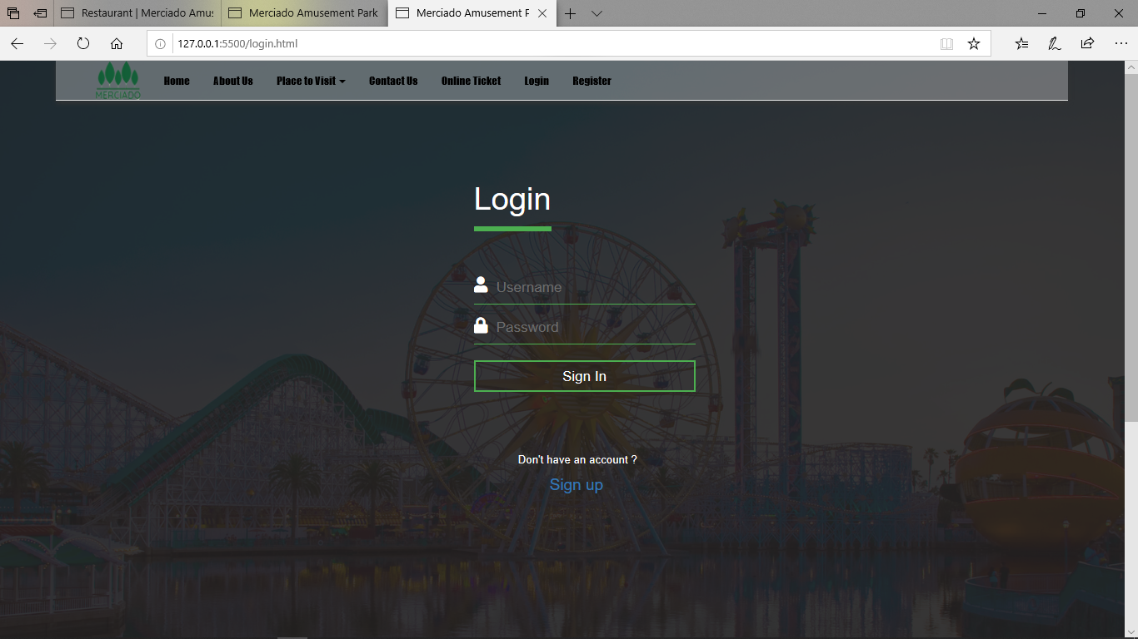

**The purpose of page**: To allow users to log in, and use the site with user rights.

**From page**: Linked from in header part of the main interface.

**Links to**: Return to Login page.

All other functions are as in the main interface

8-Register

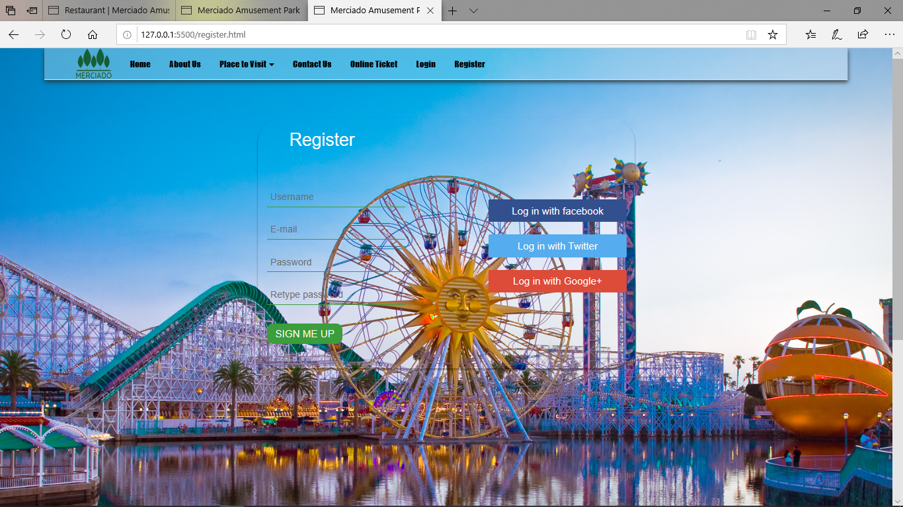

**The purpose of page**: To allow users to register for an account and to use the site with user rights.

**From page**: Linked from the login section of the menu bar.

**Links to**: Return home page.

All other functions are as in the main interface

**9,The script commands are included in the lesson**

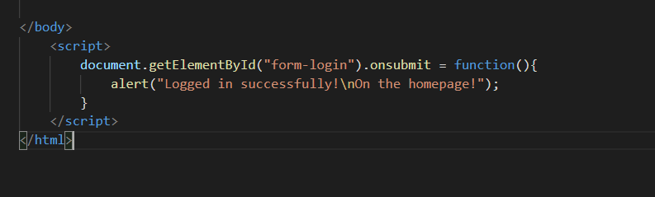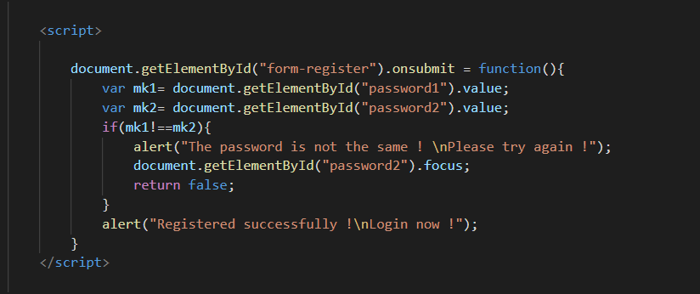

**TASK SHEET REVIEW 3**

|  |  |  |  |  |
| --- | --- | --- | --- | --- |
| **No** | **Page Name** | **Begin Date** | **TeamMate Name** | **Notes** |
| 01 | Home page | 7/10/2019 | Duc |  |
| 02 | Restaurant | 7/10/2019 | Quynh |  |
| 03 | Gallery | 7/10/2019 | Kien |  |
| 04 | Entertainment | 7/10/2019 | Vuong |  |
| 05 | Contact Us | 7/10/2019 | Quynh |  |
| 06 | Online-Ticket | 7/10/2019 | Vuong |  |
| 07 | About us | 7/10/2019 | Kien |  |
| 08 | Login | 7/10/2019 | Duc |  |
| 09 | Register | 7/10/2019 | Duc |  |
| 10 |  |  |  |  |

|  |  |
| --- | --- |
| **Date:** | |
| Signature of Instructor:  **LE MONG THUY** | Signature of Team Leader:  **PHAM ANH DUC** |